Android Application User Guide for Event Registration System

**Prior Event Preparation**

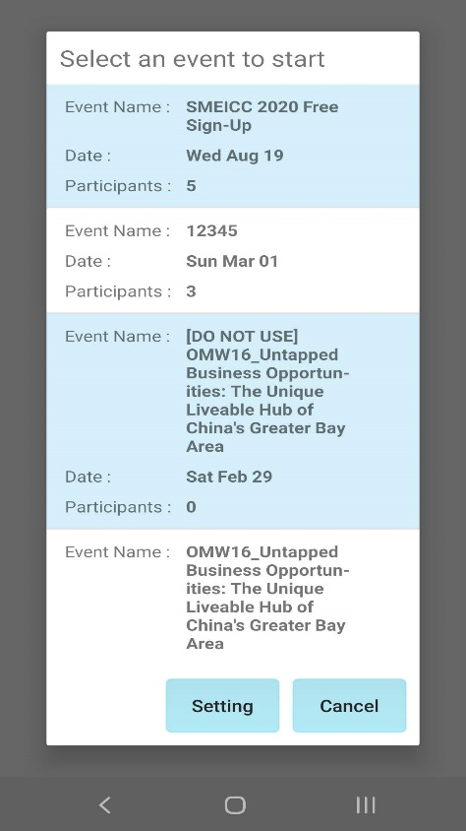 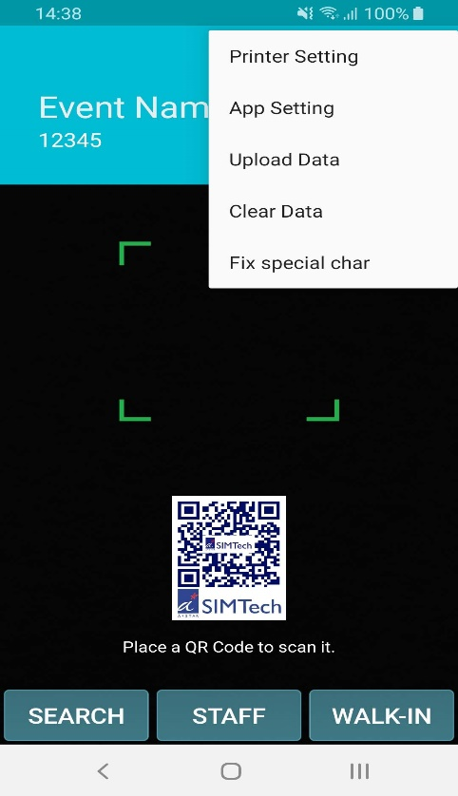

* Step 1: **Launch** ERS SCCCI App, **Select** the next happening event, it will sync down all the participants details into the device storage
* Step 2: Press **Printer Setting (see next page)**
* Step 3: Press **App Setting (see next page)**

**Prior Event Preparation (continue)**

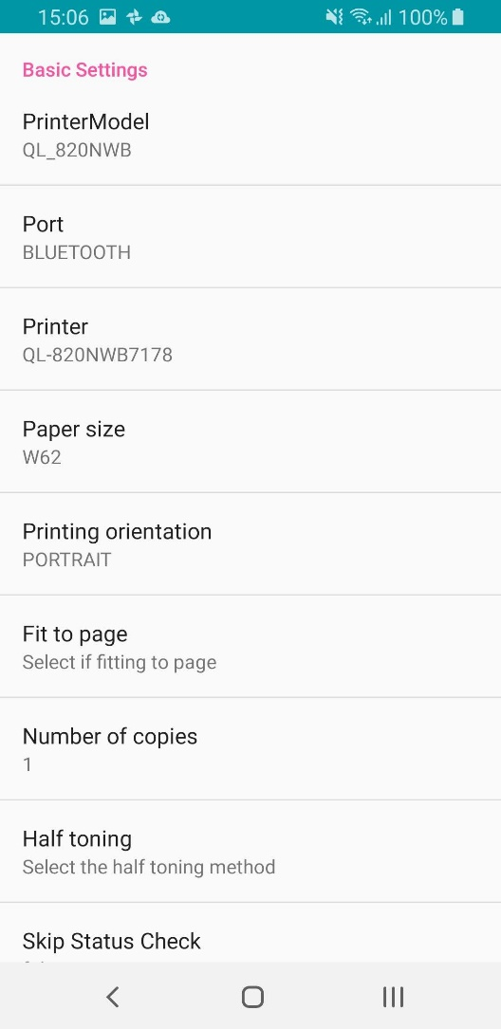**Prior Event Preparation(continue)**

**Step 2 Printer Setting Page**

* Printer Model: Make sure **QL_820NWB** is selected
* Port: Make sure **Bluetooth** is selected
* Printer: Make sure you have selected the correct printer, e.g., if **QL-820NWB7178** is selected then make sure it matches the printer label pasted is **7178**
* Paper size: Make sure **W62** is selected
* Leave the other options **default**

**Step 3 App Setting**

Server IP: Leave it **default**

Template Number: Input the **Template Number** you want to use for the event

Print Label: Select whether to **print** or **not** for Label Stickers

Extra Fields: Make sure this is **unselected**.

Mode: Make sure **Offline** is selected

Scanner: make sure **Camera** is selected

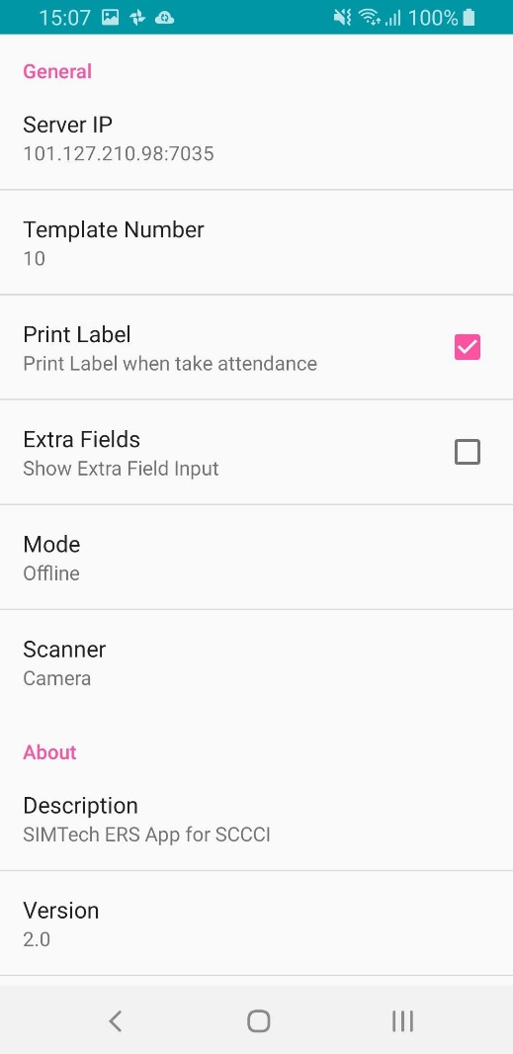

**During Event Registration**

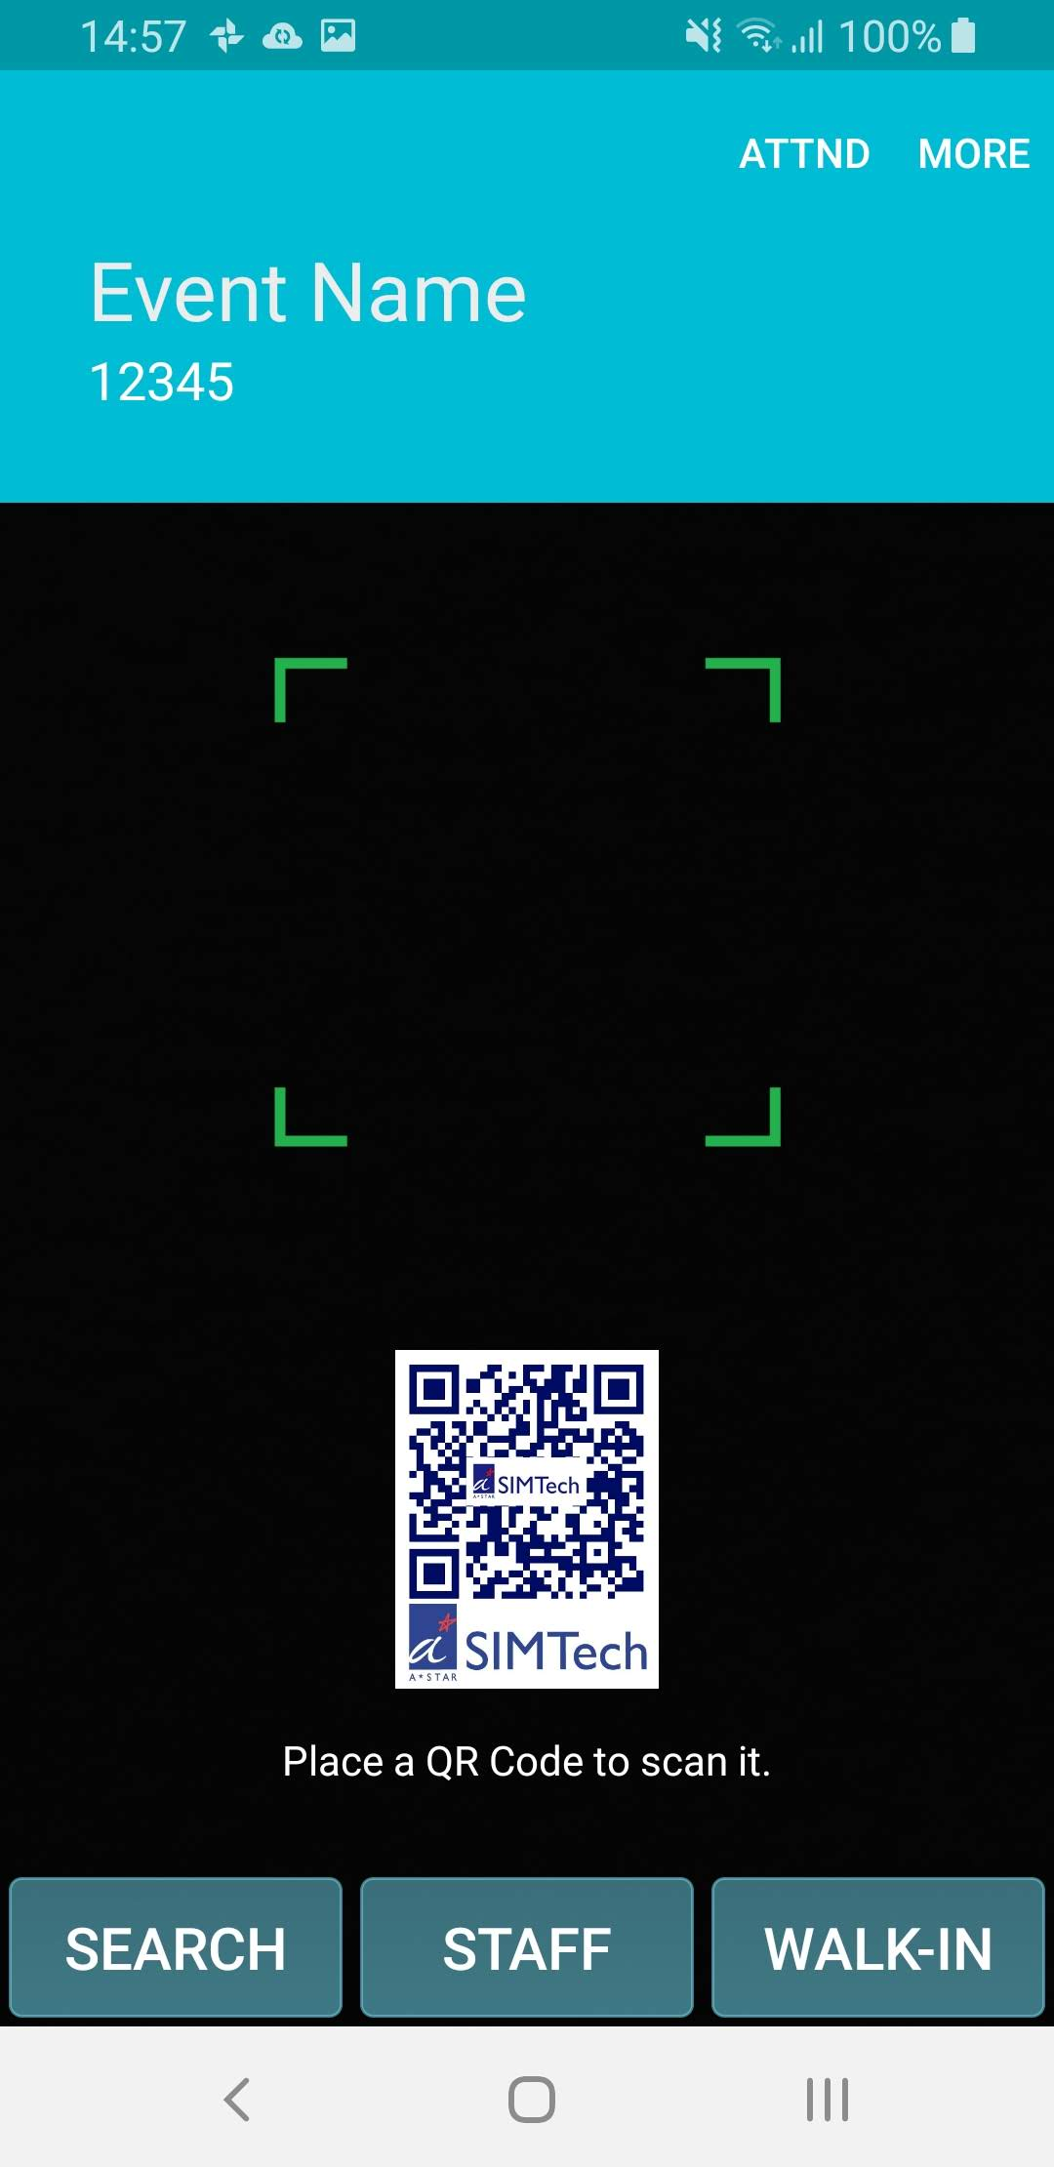

* For **Registered** Participant **with** QR-Code: Scan their QR-code directly from this screen.
* For **Registered** Participant **without** QR-code: Press **SEARCH** and do a manual search on their **name/company**
* For **Un-Registered** Participant (Walk-in): Press **WALK-IN** and **fill up** the form

**After Event**

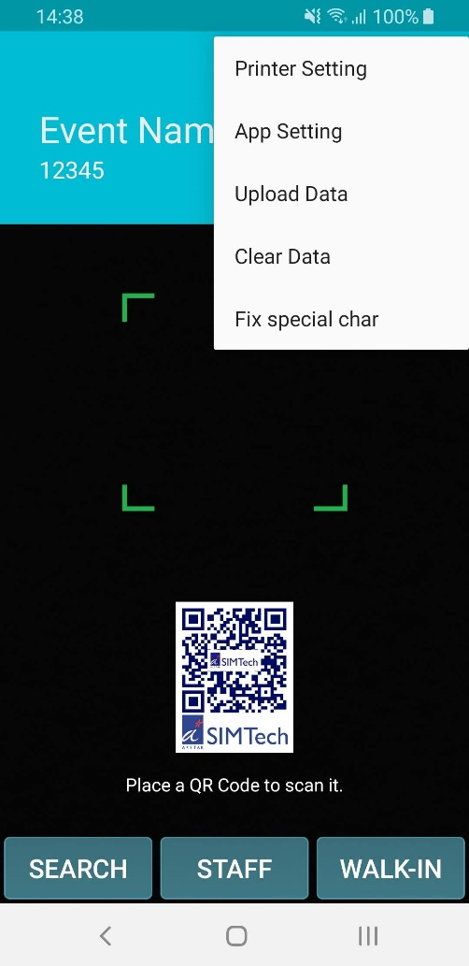

* Upload Data: Press to **UPLOAD** attendance data stored on this device back to Database Server. (Make sure you see a ‘upload success’ message)
* Clear Data: Press to **ERASE** data stored on this device without uploading, normally for **TESTING** purpose.
* Fix Special Char: Press this if you encounter problems uploading then try upload again, it might fix the problem

**Technical Support**

If you have problems with ERS Android Application, please contact

Technical support team:

[shawsa@simtech.a-star.edu.sg](mailto:shawsa@simtech.a-star.edu.sg)

[rama@simtech.a-star.edu.sg](mailto:rama@simtech.a-star.edu.sg)

Your valuable comments and suggestions on improving ERS are welcomed!